**COLLEGE OF SCIENCES ELIBRARIUM: AN ONLINE**

**LIBRARY ACCESS FOR THE PALAWAN STATE**

**UNIVERSITY, QUEZON CAMPUS.**

A Capstone Project Presented to the

Faculty of the College of Sciences

Palawan State University

In Partial Fulfillment of the

Requirements for the Degree of

Bachelor of Science in Information Technology

By

Cuyos, Justine Paul I.

Dulman, Kent Daniel E.

Escalante, Jeanamae E.

Gualdrapa, Jamyca Jeielle J.

Layba, Maryjoy A.

Urdelas, Alyza O.

**2024**

i

**TABLE OF CONTENTS**

**PAGE**

TITLE PAGE. . . . . . . . . . . . . . . . . . . . . . . i

TABLE OF CONTENT. . . . . . . . . . . . . . . . . . . .ii

LIST OF FIGURES. . . . . . . . . . . . . . . . . . . . .v

LIST OF TABLES. . . . . . . . . . . . . . . . . . . . .vii

LIST OF TABLES

CHAPTER I – INTRODUCTION

* Background of the Project. . . . . . . . . 3
* Statement of the Problem. . . . . . . . . .6
* Objectives of the Project. . . . . . . . . 7
* Significance of the Study. . . . . . . . . 8
* Scope and Limitations of the Project. . . .10

Chapter II - REVIEW OF RELATED LITERATURE

* Foreign Literature. . . . . . . . . . . . . 11
* Local Literature. . . . . . . . . . . . . . 19
* Foreign Studies. . . . . . . . . . . . . . .27
* Local Studies. . . . . . . . . . . . . . . .37

Chapter III – TECHNICAL BACKGROUND

* Physical Architecture. . . . . . . . . . . .45
* Organizational Chart. . . . . . . . . . . . 48
* List of Hardware specifications used in developing the system. . . . . . . . . . . .53

ii

* List of Software specifications used in developing the system . . . . . . . . . . . 55
* List of Hardware specifications for the implementation of the system 56
* List of Software specifications for the implementation of the system. . . . . . .57

Chapter VI – METHODOLOGY

* Conceptual Framework. . . . . . . . . . . .59
* Requirements Analysis. . . . . . . . . . . 60
  + - * Use Case. . . . . . . . . . . . . . . . 60
      * User Stories. . . . . . . . . . . . . . 62
      * System/Software Requirements

Specification. . . . . . . . . . . . . .62

* Requirements Documentation. . . . . . . . .67
* Design Of Software, Systems, Product, And/Or Processes. . . . . . . . . . . . . . . . .69
* Data Flow Diagram. . . . . . . . . . . .75
* Entity Relationship Diagram. . . . . . .76
* Network Topology and Architecture. . . .77

Chapter V – RESULTS AND DISCUSSION

* Development And Testing. . . . . . . . . . 79
* Implementation Plan

(Infrastructure/Deployment). . . . . . . . 86

* Implementation Results. . . . . . . . . . .91
* Results And Discussion. . . . . . . . . . .92

iii

Chapter V – CONCLUSIONS AND RECOMMENDATIOS

* Conclusion. . . . . . . . . . . . . . . . 102
* Recommendations. . . . . . . . . . . . . .104

iv

LIST OF FIGURES

Figure 1.0: *Physical Architecture of the System. . . .* 45

Figure 1.1: *Organizational Chart. . . . . . . . . . .* 48

Figure 1.2: *Admin Flowchart. . . . . . . . . . . . . .* 45

Figure 1.3: *User Flowchart . . . . . . . . . . . . . .* 50

Figure 1.4: *Conceptual Framework . . . . . . . . . . .* 59

Figure 1.5: *Admin Use Case . . . . . . . . . . .* . . . 60

Figure 1.6: *User Use Case. . . . . . . . . . . . . . .* 59

Figure 1.7: System*/Software Requirements Specification Functional. . . . . . . . . . . . . . . . . . . . . . .*59

Figure 1.8: *Design of Software to Create Account. . . .*69

Figure 1.9: *Design of Software to Login. . . . . . . .* 70

Figure 2.0: *Entity Relationship Diagram. . . . . . . .* 76

Figure 2.1*: Network Topology and architecture. . . . .* 77

Figure 2.3: *System Infrastructure. . . . . . . . . . .* 86

Figure 2.4: *System Deployment. . . . . . . . . . . . .* 87

Figure 2.5: *Network Topology. . . . . . . . . . . . . .*88

Figure 2.6*: Deployment Diagram. . . . . . . . . . . . .*90

Figure 2.6.1*: Survey Question 1. . . . . . . . . . . .* 92

Figure 2.6.2: *Survey Question 2. . . . . . . . . . . .* 93

Figure 2.6.3: *Survey Question 3. . . . . . . . . . . .* 94

V

Figure 2.6.4: *Survey Question 4. . . . . . . . . . . .* 95

Figure 2.6.5: *Survey Question 5. . . . . . . . . . . .* 96

Figure 2.6.7: *Survey Question 7. . . . . . . . . . . .* 98

Figure 2.6.8: *Survey Question 8. . . . . . . . . . . .* 99

Figure 2.6.9: *Survey Question 9. . . . . . . . . . . .* 100

Figure 2.6.10: *Survey Question 10. . . . . . . . . . .* 101

Figure 2.2.11: *Survey Question 11. . . . . . . . . . .* 102

vi

LIST OF TABLES

Table 1.3.1: *List of Hardware Specification Used in Developing the System*. . . . . . . . . . . . . . . . . . 53

Table 1.3.2: *Laptop Specifications*. . . . . . . . . . . .54

Table 1.3.3*: List of Software Specification Used in Developing the System. . . . . . . . . . . . . . . . . .* 55

Table 1.3.4: *List of Hardware Specification for the Implementation of the System. . . . . . . . . . . . . . .*56

Table 1.3.5:*List of Software Specification for the Implementation of the System. . . . . . . . . . . . . . .*57

Table 1.9.1: *Data flow Diagram. . . . . . . . . . . . . .*75

Table 2.1.1: *Development and Testing. . . . . . . . . . .*79

Vii

**Chapter I**

**Introduction**

**Background of the Project**

Traditional libraries were traditionally regarded as locations of knowledge, pose various problems to students. Navigating the shelves filled with many books can be overwhelming for students, and the short working hours limit access to information for those with busy schedules. Even when students locate the necessary information, obsolete resources or limited access to specific references impede their capacity to do complete research. In contrast, the digital age provides solutions, such as online databases and e-books, which allow for simple access to knowledge at any time and from any location. By embracing technology and developing online library systems, educational institutions may empower students to overcome these challenges and confidently pursue their academic goals.

Digital libraries play an important role in extending such interdisciplinary information support by making varied information resources available outside the physical area shared by a group of learners. One of the most significant advantages of digital libraries is that they bring together people with academic, casual, and professional learning goals.

Observing the need to bridge the gap between traditional and digital libraries, the researchers conceptualized these foreseen dilemmas and developed this project, which is intended to benefit various users of Palawan State University Quezon Campus Library, including students, faculty, librarians, and researchers.

The researchers termed their capstone project "ELibrarium" with the goal of improving academic resource accessibility while also fostering an adaptive environment for education and research. This capstone project is an innovative online library designed to improve user access and facilitate the availability of e-books at the Palawan State University Quezon Campus. This platform ensures users have quick access to the university's extensive collection of e-books, even those previously held in reserve by the librarian.

ELibrarium includes a number of features that aim to improve the user experience and make navigation easier. These features are the following:

**Categories:** Purpose Organizes resources into sections based on subjects. Categories such as E-books, Research Papers, and Theses. Filters for subject, author, publication year, or resource type. Detailed resource pages with download options.

**E-books:** This features all e-books that are divided into categories to assist users search and discover new ones, with personalized recommendations made based on the user's tastes and reading history. Also with saved bookmarks and downloads.

**Home Page:** Purpose Acts as the central hub for browsing resources and accessing announcement

**Search bar:** for finding specific books, articles, or topics. Quick access to popular categories and recommendations.

**About Us**: Purpose Shares information about the library’s mission, vision, and team. History of the library and its transition to an online system. Mission and vision statements emphasizing academic support. Profiles of library staff with roles and contact information. Contact section with email, phone number, and a feedback form.

**Announcement:** Purpose serve as a communication tool t**o** inform users about updates, service, or important events related to the library’s resource and operations.

**Admin Dashboard:** is a centralized platform that provides administrators with tools and insights to manage library’s resource, users, and operations eff**ic**iently. It acts as the control panel for overseeing all aspects ofthe online library.

**Logout:** This feature is a secure tool that protects user privacy and personal information. Users can manage their personal information, including passwords and security settings, using this function. They can as well access user guides and support tools to help them navigate the platform successfully.

**Upload books:** Librarians can upload new e-books to the platforms, thereby growing the library's offerings.

Users can access e-books online at any time and from any location, giving them flexibility and convenience when conducting research and reading. There are no restrictions on how many times a user can access a specific e-book, assuring

constant availability. The waiting period associated with physical copies is minimized when multiple users have access to the same book. "ELibrarium" can be accessed from any internet-connected device, including PCs, tablets, and smartphones. Users can search e-books, allowing them to access relevant material more quickly and accurately. As a result, consumers can only download e-books in limited quantities.

**Statement of the Problem**

**General Problem**

The general problem of this study is the absence of storage of books that are accessible for users.

**Specific Problems**

1. Faced an issue when trying to find books in library.
2. Absence of the availability of books.
3. Limited Number of Books.
4. Outdated book inventory.
5. **Limited library operating hours.**

**Objectives of the Project**

* **General Objective**

To create this project website entitled "Elibrarium: An Online Library Access for The Palawan State University, Quezon Campus" to address the constraints of limited physical space in traditional libraries. The website will offer digital alternatives for accessing a variety of content, aiming to reduce the necessity of searching through printed books because of spatial limitations.

* **Specific Objectives**

1. To improve search capabilities through a user-friendly digital catalog.
2. To enhance storage efficiency with compact shelving solutions.
3. To increase access to books via digital libraries and interlibrary.
4. To implement space-saving strategies like modular furniture and digitization projects.

**Significance of the Project**

eLibrarium aims to provide the librarian with an improved method in the sector. The following, in the researcher's opinion, would greatly benefit from this study:

**Students**

(1)Access books,(2)Cost of usage, (3)Enhancing research capabilities

**Faculty**

(1)Additional books of reference, (2) Enhance teaching resources, (3) Reduce workload

**Librarian**

(1)Streamlines management task, (2)Generate new content, (3)Determine what is useful and what is not

**Facility**

(1)Small facility but more books online, (2)Modernized campus infrastructure, (3)Optimize space utilization.

**Researchers**

(1)Serves as future reference, (2)Offering wealth of scholarly materials and archival resources to support their research endeavors, (3)Facilitating ongoing scholarship and knowledge dissemination.

**Scope and Limitations of the Project**

The "Elibrarium" capstone project aims to develop an online platform tailored for students and instructors at PSU Quezon Campus, providing access to a comprehensive range of ebooks and learning materials pertinent to their courses. The platform will feature advanced search and filter options, and reading enhancements to optimize the user experience across various devices.

Despite its ambitions, the "Elibrarium" project faces several limitations. These include potential constraints on content availability due to publishers' agreements, reliance on stable internet connections for access, and the possibility of limited compatibility with older devices or software versions. Additionally, ensuring security against potential threats such as data breaches remains a concern, and providing timely support services may be challenging due to resource constraints. Maintaining content quality control, particularly with user-generated or third-party contributions, also presents a significant challenge.

**CHAPTER II**

**Review of related literature**

**Foreign Literature**

As mentioned in the study of Thangiah et al., (April 2024). Digital Transformation of Academic Libraries. Academic libraries are essential for providing information services to the user community. Historical initiatives have been implemented to establish these libraries based on recommendations from commissions on education. The chapter discusses the digital transformation of academic libraries, focusing on automation, digital library services, digital reference services, INFLIBNET services, digital initiatives in India for higher education, artificial intelligence in libraries, and resource digitization.

**Synthesis**

The article Digital Transformation of Academic Libraries explores how academic libraries are adapting to the rapid advancements in digital technology to better serve their users. It discusses how the integration of digital tools and services has reshaped library functions, enhancing access to information, improving resource management, and offering new avenues for user engagement. The study emphasizes key components of this transformation, including the automation of library systems, the development of digital libraries, and the shift to providing digital reference services.

A major focus of the article is on how digital platforms enable libraries to offer a more diverse range of services, such as online databases, e-books, and virtual reference assistance, making academic resources more accessible to students and researchers. The research also highlights the role of initiatives like INFLIBNET in India, which supports academic collaboration and resource sharing across institutions.

The article further examines the application of artificial intelligence (AI) in libraries, noting its potential to revolutionize tasks such as information retrieval, resource discovery, and personalized user experiences. AI is seen as a tool that can significantly improve the efficiency of library operations, from automating cataloging processes to enhancing search functions.

Lastly, the study addresses the challenges and opportunities that digital transformation presents to academic libraries. While the shift to digital services offers numerous benefits, such as increased accessibility and the ability to serve a larger user base, it also requires libraries to invest in new technologies, train staff, and ensure that digital content remains secure and accessible.

The article underscores the ongoing digital evolution of academic libraries, demonstrating how these changes are essential for libraries to remain relevant and effective in the modern educational landscape.

As mentioned in the study of mandrekar et al., (September 2020). IMPACT OF ACADEMIC LIBRARY SERVICES ON STUDENTS’ SUCCESS AND PERFORMANCE. Libraries play an important role as a reliable and beneficial information provider in the students’ academic success and performance. The aim of this study is to investigate the student’s satisfaction with library resources and services provided by the academic library. Random surveying was conducted to find out the problem and difficulties faced by the students in accessing the library resources and its impact on their academic success and performance. The finding in the study showed that there is a significant and remarkable relationship between the library usage and the students’ academic performance and success. the major finding of the study is to conduct the information literacy programmed for the students to promote awareness about the resources, services and facilities available in the library so that the students can take maximum advantage of the benefits provided by the library. One way to overcome this problem is to encourage the students to embrace using the library in their academic studies and explain its benefits.

**Synthesis**

The study titled "Impact of Academic Library Services on Students’ Success and Performance" explores the relationship between the use of library services and students' academic outcomes. The researchers conducted surveys to assess students' satisfaction with library resources and to identify the challenges they face in accessing these services.

The findings reveal a clear positive correlation between the usage of academic library resources and students' academic performance. Students who regularly use library services, such as borrowing books, accessing digital resources, and utilizing library spaces for study, generally perform better academically. The study emphasizes that library resources go beyond just providing books, highlighting the importance of digital resources, research support, and access to study materials that contribute to academic success.

One of the major recommendations of the study is the implementation of information literacy programs. These programs aim to educate students about the full range of resources and services available in the library, ensuring they can make the most of these tools for their academic benefit. Information literacy can empower students to use the library more effectively, improving their research skills and overall academic performance.

The study also points out that library staff play a critical role in helping students navigate available resources. The support provided by staff, including guidance in finding and using materials, significantly impacts students' ability to succeed.

The study suggests that academic libraries are vital to students' educational experience, and maximizing the use of library services can lead to improved academic outcomes. Encouraging greater student engagement with library services and ensuring they are well-informed about the resources available can help students reach their full academic potential.

Igwe ukoha (October 2020). Libraries Without Walls and Open and Distance Learning in Africa: The Nigerian Experience. Open and Distance Learning (ODL) is gradually gaining ground in Africa. Even though ODL in Africa is still saddled with teething problems, workers, politicians, school leavers and the general public are trooping into ODL institutions to acquire education. Nigeria is a new comer in Open and Distance Learning. The experiences of several open and Libraries are indispensable in every facet of higher education. Effective library support to distance learners is mandatory for qualitative delivery of instruction and learning. Information and Communications Technology (ICT) has transformed all aspects of society particularly information dissemination. The development of libraries without walls has definite benefits to distance learners. Developed and developing countries are creating Virtual learning environments and libraries without walls to reach multitudes of learners at various locations. This paper examines the general experiences of Open and Distance Learning in Africa, the evolution of ODL in Nigeria and the structure of library services provided to distant learners particularly in Nigeria. It examines the challenges in creating and providing library without walls for distance education and the prospects of library without walls in a developing country like Nigeria. The paper will also present a discussion on how NOUN is developing creative solutions to the challenges.

**Synthesis**

The article Libraries Without Walls and Open and Distance Learning in Africa: The Nigerian Experience explores the role of libraries in supporting open and distance learning (ODL) in Africa, with a particular focus on Nigeria. It examines how libraries have adapted to the growing demand for flexible learning options by providing remote access to resources and services. The term "libraries without walls" is used to describe libraries that extend beyond physical buildings, offering services like digital resources, virtual reference services, and online learning platforms to support students in non-traditional educational settings.

The study highlights the importance of academic libraries in facilitating ODL, which allows learners to study independently, often from remote locations, without the need to attend traditional classroom settings. In the context of Nigeria, the article discusses how libraries have become central to the success of ODL programs, providing vital resources such as e-books, online journals, and access to digital learning materials. It also emphasizes the need for libraries to develop digital infrastructures and services to support the increasing number of students enrolling in distance learning programs.

The article further examines the challenges faced by Nigerian academic libraries in providing adequate support for ODL. These challenges include limited access to technology, insufficient funding, and inadequate training for library staff. Despite these obstacles, the study suggests that libraries can play a key role in improving the quality and accessibility of education in Nigeria by embracing technology and expanding their digital offerings.

Through this analysis, the article underscores the significance of libraries without walls in the context of ODL in Africa, particularly in Nigeria, where digital access can overcome geographical and infrastructural limitations to education.

**Local Literature**

Panhilason (2024). Users’ Awareness, Utilization, and Satisfaction with Online Library Information Resources and Services. Libraries are the support system for the academic success of students and teachers. These have been proven when libraries were greatly affected during the COVID-19 pandemic. There was a shift from on-site to online library services, and various library innovations were implemented to support the academic community despite the COVID-19 pandemic challenges. This study examined the online library information resources and services at Carlos Hilado Memorial State University in terms of users' awareness, utilization, and satisfaction. A researcher-made questionnaire was used, validated by five (5) experts in research and library and information science, and 374 students participated. The instrument's reliability was strong, with a Cronbach's alpha coefficient of 0.910. Descriptive and inferential statistics were employed in data analysis. Mean, standard deviation, t-test, ANOVA, and Pearson's r were the statistical tools used. The results showed a high level of awareness of online library information resources and services, and the users often utilized these resources and services. Users were very satisfied with the resources and services, indicating that their needs were effectively met. Furthermore, there is a significant difference in the users' level of awareness and satisfaction when grouped according to age, year level, campus, and frequency of library usage, and no significant difference when grouped according to their sex. However, there is no significant difference in the users' extent of utilization when grouped according to age, sex, year level, campus, and frequency of library usage. As to the correlation, there is a significant relationship between users' level of awareness and their extent of utilization of online library information resources and services.

**Synthesis**

The document Users Awareness, Utilization, and Satisfaction with Online Library Information Resources and Services"\* investigates how users engage with and benefit from online library resources and services. The study focuses on understanding the level of awareness students and researchers have about available digital resources, their utilization patterns, and their satisfaction with these services. It sheds light on the evolving role of libraries in providing access to digital content, including e-books, online journals, databases, and other electronic resources.

The research reveals that while a significant number of users are aware of the online resources available in libraries, many do not fully utilize them. The primary reasons for underutilization include lack of knowledge on how to access or navigate digital platforms, limited training on available services, and sometimes, difficulty in accessing resources due to technical issues. The study also highlights that user satisfaction is closely linked to the ease of use of online platforms, the range of available resources, and the effectiveness of support services such as online reference and research assistance.

The findings emphasize the need for libraries to not only promote awareness of their digital resources but also provide adequate training and support to help users make the most of these services. Users who received training or guidance on using online resources reported higher levels of satisfaction and were more likely to utilize library services regularly.

The document emphasizes the need to increase user awareness, improve access to online resources, and provide continuous support to maximize the use of digital library services. It highlights that while many users are aware of available online resources, there is often a gap in utilization due to lack of knowledge on how to access or navigate the platforms. The study suggests that providing proper training and guidance can significantly improve user engagement and satisfaction with these resources. Additionally, it notes that users who receive support, such as online reference services, report higher satisfaction and are more likely to use the library's digital offerings effectively.

Isip et al., (2023). Challenges to Digital Services in Philippine Academic Libraries. This paper seeks to characterize the maturity of digital initiatives in Philippine academic libraries, focusing on the sustainability of digitization activities. For its literature review, this paper presents local digitization initiatives, guidelines, standards, and good practices on digitization as presented in research, and prevailing digital library services during the COVID-19 pandemic. It employed a descriptive-comparative research design to obtain information on digitization programs implemented in higher education and research-producing institutions. Five of the 12 verified institutions with digitization programs were engaged for further interviews. The respondents cited the lack of staff, dedicated physical space, and inadequate equipment and funding as barriers to implementing a digitization program. Most of the respondents’ digitization initiatives began in response to external triggers rather than as a part of a comprehensive strategy to provide digital library services. The project-based approach to these activities affects the sustainability of digitization programs. The study recommends organizing more consultancy programs in digitization, teaching digitization ICT applications in LIS schools, information companies offering digitization services, digitization communities of practice, and consortia for sharing facilities and expertise. With the requirements of a more robust digital framework to provide flexible access, Philippine academic libraries must review their short- and long-term goals and figure out where digitization can be integrated within said goals.

**Synthesis**

In the article Challenges to Digital Services in Philippine Academic Libraries by Lagas and Isip (2023), the authors explore the barriers faced by academic libraries in the Philippines as they transition to offering digital services. The study identifies several key challenges, including inadequate infrastructure, limited access to technology, and the lack of trained personnel to manage and support digital services. These obstacles hinder the effective implementation and use of digital library services, which are crucial for meeting the demands of a growing academic community.

The article discusses how insufficient funding affects the ability of libraries to invest in necessary digital tools, platforms, and resources. This limitation is further compounded by inconsistent internet connectivity, particularly in rural or less-developed areas, making it difficult for libraries to maintain seamless digital access for users. The authors also highlight the need for ongoing professional development for library staff to ensure they are equipped to handle new technologies and provide effective support to library users.

Despite these challenges, the study emphasizes the importance of addressing these gaps to improve digital service delivery in academic libraries. The authors suggest that collaborative efforts between government, educational institutions, and library associations are essential to overcome these obstacles and ensure the sustainability of digital services in Philippine academic libraries.

Agustian et al., (May 2021). E-book limitation with library portable document format java script for accessing digital library. The function of the Adisutjipto-Aerospace Institute of Technology (ITDA) library is to provide borrowing and reimbursement services for books insured by members of the library. The books which increase in number each year occupy a lot of space in the library, it is therefore necessary to study it so that the form of this book is no longer physical but digital or paperless to be able to be stored on a server computer. This form of library is known as a digital library or e-library. The electronic library is a modern library as a place which provides a source of educational information with more convenience and security. The flow in the application is not very different from the flow in the manual library. Security becomes an important part of an application, by limiting network access, accessing PDF documents and implementing PDF Viewer using the PDF.js library by rendering PDF documents on a canvas capable of blocking illegal downloads. Based on the test results, the electronic library application can work properly. The speed of opening a PDF document is influenced by the speed of the server, the content contained in the PDF and the size of the PDF file.

**Synthesis**

In the article E-book Limitation with Library Portable Document Format JavaScript for Accessing Digital Library by Agustian and Nugraha (2021), the authors examine the limitations of using Portable Document Format (PDF) and JavaScript in accessing e-books through digital libraries. The study discusses technical challenges faced by users when trying to access and interact with digital library resources, particularly e-books, which are commonly stored in PDF format.

The authors highlight issues related to the compatibility of e-books with various devices and software, as well as limitations in the functionality of PDF files, such as difficulties in navigation, searchability, and interactive features. They also address the challenges libraries face in maintaining and updating their digital collections to ensure compatibility with the latest software and platforms.

The study suggests that improvements are needed in the integration of digital library systems and e-book formats to enhance user experience and accessibility. It proposes potential solutions, such as the development of more flexible file formats and the use of advanced JavaScript techniques to enable smoother interaction with e-books across different platforms and devices. The authors stress the importance of optimizing e-book access to ensure that digital library resources are usable, accessible, and effective for all users.

**Foreign Studies**

Khan (November 2021). Importance of Digital Library in Education. During the past recent years, there has been tremendous development reaming the concept of digital libraries, the biggest online platform of knowledge that can be stored and retrieved through online networks. Digital libraries are considered as the most complex form of data systems that associate with the digital document preservation, distributed database management, hypertext, filtering, information retrieval, and selective dissemination of information. This has really overcome geographical barrier offering a wide range of academic, research, and cultural resources with multimedia effects which can be accessed around the world over the distributed networks. The study also highlighted the information on the digital library projects undertaken in countries. This article provides information to the audience on the subject matter in terms of what has been already discovered and explored on the importance of Digital Library and what all can be further explored. The literature pertaining to the studies relating to how digital libraries emerged discussed in this article. The idea is to brief the readers about the concept of library resources shifted into digital libraries with the help of technology and its growth sourced from already existing literature. The contemporary trends reflecting the current state of the library and how it has progressed over time also discussed.

**Synthesis**

In the article Importance of Digital Library in Education by Khan (2021), the author examines how digital libraries are transforming the educational landscape by providing essential resources and services that enhance learning and research. The study highlights the increasing reliance on digital libraries to provide access to a wide array of academic materials, including e-books, research articles, journals, and multimedia content. This is particularly significant in a time when education is increasingly shifting towards online and blended learning models.

The article emphasizes the role of digital libraries in improving access to information, allowing students and educators to obtain scholarly resources anytime and anywhere. Khan points out that digital libraries support distance education by overcoming geographic and physical barriers, ensuring that learners in remote areas have the same access to educational materials as those in more developed regions.

Khan also discusses the benefits of digital libraries in research, noting that they streamline the process of finding relevant academic content through advanced search functions and digital catalogs. These tools help students and researchers save time and effort in gathering resources, thus accelerating the research process.

Additionally, the study underscores the need for continued technological advancements in digital libraries to meet the growing demands of modern education. It suggests that libraries should focus on enhancing their digital infrastructure and providing training to both users and library staff to ensure effective use of digital resources. The article concludes by stressing that digital libraries are vital to the future of education, offering a flexible and efficient way to access knowledge and support lifelong learning.

As mentioned in the study of Ogata et al., (December 2023 15(12)). Decentralized Storage with Access Control and Data Persistence for e-Book Stores. The e-book services we use today have a serious drawback in that we will no longer be able to read the books we have purchased when the service is terminated. One way to solve this problem is to build a decentralized system that does not depend on a specific company or organization by combining smart contracts running on the Ethereum blockchain and distributed storage such as an IPFS. However, a simple combination of existing technologies does not make the stored e-book data persistent, so the risk of purchased e-books becoming unreadable remains. In this paper, we propose a decentralized distributed storage called d-book-repository, which has both access management function and data durability for purchased e-books. This system uses NFTs as access rights to realize strict access control by preventing clients who do not have NFTs from downloading e-book data. In addition, e-book data stored on storage nodes in the distributed storage is divided into shards using Reed–Solomon codes, and each storage node stores only a single shard, thereby preventing the creation of nodes that can restore the entire content from locally stored data. The storage of each shard is not handled by a single node but by a group of nodes, and the shard is propagated to all nodes in the group using the gossip protocol, where erasure codes are utilized to increase the resilience against node departure. Furthermore, an incentive mechanism to encourage participation as a storage node is implemented using smart contracts. We built a prototype of the proposed system on AWS and evaluated its performance. The results showed that both downloading and uploading 100 MB of e-book data (equivalent to one comic book) were completed within 10 s using an instance type of m5. large. This value is only 1.3 s longer for downloading and 2.2 s longer for uploading than the time required for a simple download/upload without access control, confirming that the overhead associated with the proposed method is sufficiently small.

**Synthesis**

The article Digital Libraries and Their Impact on Education: A Review (2023) explores the significant role that digital libraries play in the modern educational landscape. The author reviews various studies and initiatives aimed at integrating digital libraries into educational systems, emphasizing how these resources enhance access to learning materials and improve the quality of education.

The paper discusses the various advantages of digital libraries, including their ability to provide round-the-clock access to a wide range of academic resources such as e-books, journals, and research papers. This accessibility is particularly important in supporting distance learning and higher education, where students may not have easy access to physical libraries. By offering remote access to essential educational materials, digital libraries ensure that learners and researchers can continue their studies without the limitations of geographical or institutional boundaries.

Furthermore, the article highlights the role of digital libraries in promoting academic research. By providing efficient search tools and easy access to scholarly articles, digital libraries enable users to conduct more comprehensive and effective research. The review also addresses the challenges digital libraries face, such as the need for robust technological infrastructure, ongoing staff training, and the digitization of older academic resources.

In addition, the article explores the impact of digital libraries on educational equity, noting that these platforms can reduce disparities in access to educational resources, particularly in underdeveloped regions. The author concludes by emphasizing the growing importance of digital libraries in supporting lifelong learning and the need for continuous investment in their development to meet the needs of an increasingly digital world.

John D'Ambra a, et al., (October 2022). Digital transformation of higher education in Australia: Understanding affordance dynamics in E-Textbook engagement and use. This paper addresses digital transformation in higher education by exploring the engagement and use of e-textbooks through an affordance theory lens. Drawing on the insights from in-depth interviews (n = 18), focus group discussions (n = 15), a pilot survey (n = 83) and the main survey (n = 344) in Australia, we developed and validated an affordance actualization model for the engagement and use of e-textbooks. The partial least squares (PLS) technique was used to validate the dimensions of affordance actualization and its relationship with e-textbooks engagement and affordance effect. The findings indicate the efficacy of the two affordance constructs, as well as the significant mediating effect of engagement. An important lesson for the e-textbook industry is that firms need to consider affordance actualization dimensions (i.e., portability, accessibility, searchability, highlighting, copying, browsing, hedonic and utilitarian value) when enhancing digital engagement and use of e-textbooks.

**Synthesis**

The article Importance of Digital Libraries in Education (2023) examines the evolving role of digital libraries in enhancing education, particularly through the provision of accessible, flexible, and diverse learning resources. It highlights how digital libraries facilitate learning by offering students and educators immediate access to a wealth of academic materials, including e-books, journals, research papers, and multimedia content. This accessibility is crucial in modern education, where traditional physical libraries are often unable to meet the increasing demand for resources, especially in distance learning contexts.

The study emphasizes the significant impact of digital libraries on research, enabling more efficient and effective academic work by providing powerful search tools and easy access to scholarly information. It also discusses the challenges that digital libraries face, such as the need for robust technological infrastructure, continuous updates of digital content, and user training to ensure effective utilization. The author stresses that while digital libraries are beneficial, their effectiveness depends on overcoming these barriers to ensure equitable access to information.

Furthermore, the article explores how digital libraries support various educational levels, from K-12 to higher education, by enabling personalized learning experiences and facilitating collaboration among students and researchers. It underscores the growing importance of these resources in fostering academic success, providing opportunities for lifelong learning, and supporting global access to education. The article concludes by calling for greater investment in digital library systems and technological advancements to meet the evolving needs of the education sector.

**Local Studies**

As mentioned in the study of Abrigo et al., (2023). Teaching Information Literacy During the Pandemic: Current Practice and Challenges. Academic and school libraries in the Philippines now offer online library instruction to assist students and faculty members with their learning and research needs. The study documents the current practices of librarians in conducting online library instruction in response to the challenges brought about by the COVID-19 pandemic. It examines the challenges associated with online library instruction as they transition back to face-to-face instruction. An online questionnaire was distributed to collect data from academic and school librarians who had experience with online library instruction during the pandemic. During the transition to online instruction, the major challenges were: (1) librarians’ and students’ access to technologies, (2) stable internet connection, and (3) keeping students engaged. This study provides valuable information to library managers and institutional administrators to better understand the experiences and viewpoints of librarians in facilitating the adoption, acceptance, and use of online instruction.

**Synthesis**

In the article Teaching Information Literacy During the Pandemic: Current Practice and Challenges by Abrigo, Eclevia, Samson, and Viray, the authors explore the shift in teaching information literacy skills to students during the COVID-19 pandemic. The study examines how academic libraries and educators adapted their information literacy instruction to the challenges posed by remote learning environments.

The article highlights that, with physical libraries closed and traditional face-to-face instruction unavailable, librarians and educators were forced to transition to online teaching methods. This shift required the development of new strategies for teaching students how to navigate and critically evaluate information in digital spaces. The authors discuss various approaches to online instruction, such as virtual workshops, webinars, and the creation of digital learning materials, which aimed to teach students how to effectively use online library resources, search databases, and evaluate information sources.

Despite these efforts, the study also identifies several challenges that arose during the pandemic. One key issue was the lack of digital literacy among some students, which made it difficult for them to engage with online resources effectively. Furthermore, the authors note that there was a lack of access to technology in some regions, which compounded the difficulties faced by students in participating in online information literacy programs.

The article concludes by emphasizing the importance of adapting information literacy instruction to the digital age while also addressing the barriers that prevent equitable access to these skills. The authors suggest that future efforts should focus on creating more inclusive and accessible information literacy programs, integrating these skills into the curriculum, and ensuring that students are prepared for the increasing reliance on digital resources in their academic and professional lives.

Calilung (March 2024). LIBRARIANS IN TRANSITION: EMPOWERING KNOWLEDGE SEEKERS IN THE DIGITAL AGE. Libraries have historically served as essential hubs for information access and education. Traditionally viewed as repositories of books, libraries are now undergoing a metamorphosis. This qualitative research explores the evolving roles of librarians in the "new normal," particularly their function as scaffolds and knowledge acquisition guides. The study analyzes ten academic publications (1975-2021) on the changing roles of libraries. Employing a thematic analysis approach, the research reveals librarians transitioning into new roles: knowledge developers, collaborators, content curators, trainers, and information managers. These findings highlight how librarians are adapting to empower knowledge seekers in the digital age.

**Synthesis**

In the article Librarians in Transition: Empowering Knowledge Seekers in the Digital Age, the authors explore how the role of librarians has evolved in response to the digital transformation of information access and the growing need for digital literacy. The study examines the shifting responsibilities of librarians as they transition from traditional custodians of physical resources to facilitators of digital information and technology.

The article discusses the expanded role of librarians in supporting information literacy, particularly in the digital age where information is abundant, but not always reliable. Librarians are increasingly tasked with guiding users through complex information systems, teaching them how to evaluate sources, and helping them navigate digital platforms effectively. This requires librarians to develop new skills and adopt technologies that allow them to manage digital content, assist with online research, and provide virtual reference services.

The authors also highlight the importance of empowering users—particularly students and researchers—by promoting critical thinking and digital literacy skills. Librarians are seen as key players in ensuring that knowledge seekers are equipped to access, evaluate, and use information responsibly in an increasingly digital world. However, the study also points out several challenges that librarians face in this transition, such as the need for continuous professional development, adapting to new technologies, and overcoming resistance to change in traditional library systems.

The article concludes by emphasizing the need for librarians to continuously adapt to the changing information landscape while maintaining their core mission of supporting education and lifelong learning. Empowering knowledge seekers in the digital age requires librarians to stay ahead of technological trends, collaborate with faculty and other educators, and remain committed to the principles of information accessibility and equity.

Josiah Ramuel Narca. COVID 19 Pandemic and the Library Online Services. The purpose of this study is to describe the experiences of St. Scholastica's College Manila High School librarians in implementing library online services during the COVID-19 Pandemic. The researcher used a descriptive research design and employed Document Analysis and Thematic Analysis vis-a-vis the respondents' answers on the electronic questionnaires. It was revealed, through this study, that the roles and responsibilities of the SSC Manila HS librarians were technologists, online learning support professionals, instructional partners, and game-based learning developers. On the other hand, they experienced challenges such as having limited transactions and time constraints in delivering library online services and the opportunities of having proactive team culture and providing appropriate and innovative services to their clientele. With these findings, the following are recommended for better library online services of the school libraries and librarians. First, librarians and staff's technical competencies and skills must continuously be honed. Second, the library's online services must also be evaluated annually by the students and faculty members. Third, the librarians and staff must explore more technological applications or apps and learning management systems. Lastly, further research studies are recommended in relation also to delivering library online services that can be in the contexts of other types of libraries, most especially their experiences so that there will be a deeper and bigger understanding of the roles and responsibilities, and the challenges and opportunities of librarians during the COVID-19 Pandemic.

**Synthesis**

In the article COVID-19 Pandemic and the Library Online Services: SSC Manila High School Librarians' Experiences, Narca (2021) investigates the experiences of librarians at San Sebastian College (SSC) Manila in adapting to online library services during the COVID-19 pandemic. The study explores how the sudden shift to remote learning posed both challenges and opportunities for high school libraries, particularly in maintaining access to library resources and supporting student learning in an online environment.

The article discusses how SSC Manila librarians quickly transitioned to providing online services, including virtual reference assistance, digital resource access, and virtual library orientations. The study reveals the difficulties librarians faced in mastering new technologies and managing the increased workload of maintaining digital platforms, while also dealing with the emotional toll of not being able to interact physically with students. The authors highlight the creativity and resilience of librarians who found innovative ways to engage students, such as through social media, online storytelling sessions, and virtual workshops.

Despite the challenges, the study underscores the importance of the transition to digital services for the continuity of learning. It suggests that this experience has not only highlighted the critical role libraries play in supporting education but also created an opportunity for librarians to expand their digital skills and improve library services in the long term. Narca concludes by emphasizing the need for further training and professional development for librarians, so they can continue to adapt to changing circumstances and better support students in the future.

**CHAPTER III**

**TECHNICAL BACKGROUND**

The ELibrarium is an online library initiative for Palawan State University, Quezon campus, aimed at improving access to academic resources and supporting research for students and faculty. This chapter outlines the technical background of the online library website, focusing on upgrading the existing library system to address current challenges.

**Physical Architecture**

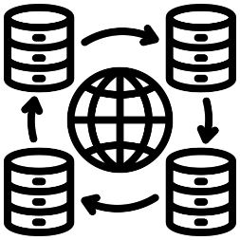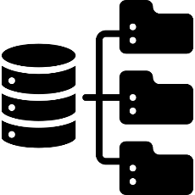User Devices Web Server Application Server

File Storage/CDN Data Server

Figure 1.0. *Physical Architecture of the System*

The physical architecture of a website consists of several key components that work together to provide a smooth user experience. Users interact with the website through devices like laptops, mobiles, or tablets, which send requests to the web server. The server delivers static content such as HTML, CSS, and JavaScript, displaying the website's structure and design.

For dynamic content, the web server forwards requests to the application server, which handles the core logic, processes user actions (like login or searching for e-books), and retrieves data from the backend. This ensures that the correct information is displayed based on user interactions.

The database server stores dynamic data, including user profiles, e-book details, and transaction history. When needed, the application server queries the database to provide personalized content to users.

For e-book and media file storage, the system uses a content delivery network (CDN) or file storage. The CDN caches static files on servers worldwide, speeding up content delivery and ensuring fast download speeds.

Together, these components—user devices, web servers, application servers, databases, and CDNs—create a seamless system for users to access, browse, and download e-books while ensuring smooth and scalable operations.

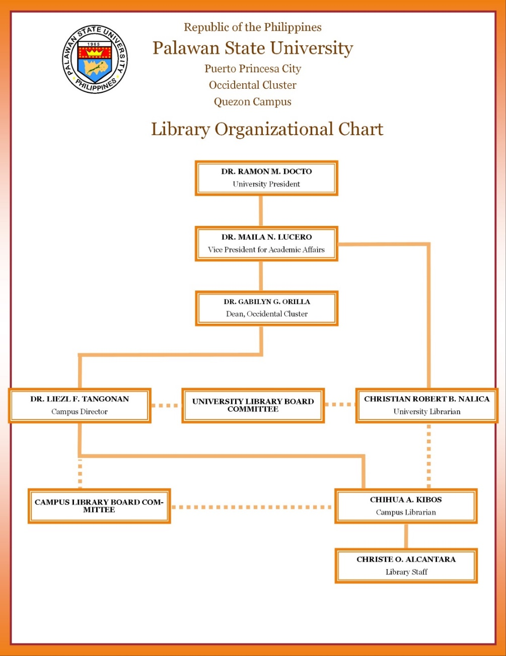**Organization chart**

Figure 1.1. *Organizational Chart*

The Elibrarium website have admin the will going to handle the user system. It is composed to tree user the admin, students, and the faculty.

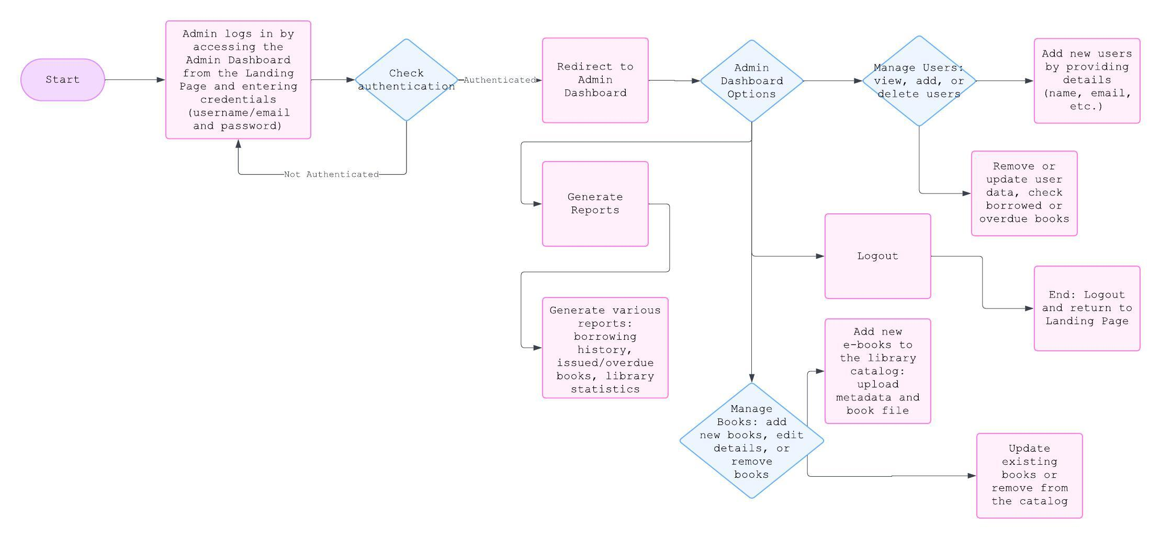 **System Flowchart**

Figure 1.2*. Admin Flowchart*

The Library Management System connects multiple entities and processes to efficiently manage library operations. Users (Library Patrons) interact with the system to search for, borrow, and return books, while Admins manage inventory, user accounts, and book transactions.

Key processes include Login/Authentication for secure access, Book Search & Browse for finding books, and Borrow/Return Books which updates the Books Database and logs transactions. Admins also Manage Users and Manage Books, including adding, removing, or updating book records. The system tracks transactions in Transaction Logs and provides the Generate Reports process for the admin to view library activity.

Data flows include Login Data, Book Information, Transaction Updates, and User Data, ensuring smooth operation and security. This structure helps admins manage the library while providing users with easy access to books.

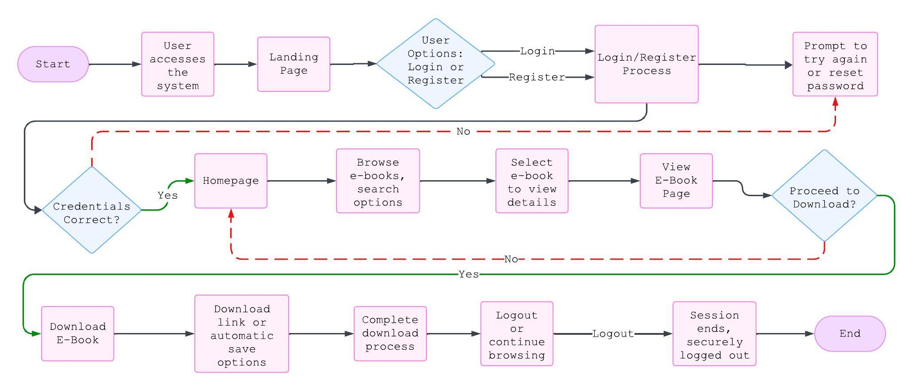**System Flowchart (User)**

Figure 1.3. *User Flowchart*

The process begins when the User (represented as an external entity in the DFD) accesses the system, either as a new visitor or a registered user. The first interaction occurs on the Landing Page, where the user is provided with options to either log in or register for an account. The landing page may also display general information about the platform, such as popular books or categories, to entice the user to proceed further. If the user is not logged in, they are given the opportunity to either enter their login credentials or create a new account.

After entering their details on the Login/Register page, the system authenticates the user’s credentials. If successful, the user gains access to the Homepage. The homepage serves as the primary point of interaction, showcasing a variety of available e-books. The e-books are typically categorized by genre, popularity, or other relevant filters, and users can browse through the options. A search feature may also be provided for users to quickly find specific titles or authors.

Once the user finds an e-book they are interested in, they can navigate to the View E-Book page. On this page, the user can examine more detailed information about the book, including a description, the author, cover images, and possibly reviews or ratings from other users. This allows the user to evaluate the book before deciding whether they want to download it.

If the user chooses to download the e-book, they can click the Download E-Books button. The system will then process the request, providing the user with a download link or automatically downloading the e-book in the chosen format (such as PDF, ePub, or any other materials). Once the e-book is successfully downloaded, the user can either continue browsing or choose to log out.

When the user has finished browsing, downloading, or simply wishes to end their session, they can proceed to Logout/End. By logging out, the system securely terminates the user’s session, ensuring their account information is protected. After logging out, the process is complete, and the user is either returned to the landing page or the session ends entirely. This flow represents a simple, intuitive journey for a user interacting with an e-book platform, from initial login to browsing, downloading, and logging out.

|  |  |
| --- | --- |
| **List** | **Use** |
| Laptops | This device will be used to documents the development of the researcher’s system. |
| Smart Phones | This device will used for research and communication purpose |
| Flash Drive | This device is used by the researchers to store important documents that need to be saved and stored for the future reference |
| Smartphone internet (hotspot), Piso WIFI | The internet, or Wi-Fi connection, is also used to access online resources that can be used in creating a thorough system proposal |

**List of Hardware Specification Used in Developing the System**

Table 1.3.1*: List of Hardware Specification Used in Developing the System*

**Laptop Specifications**

|  |  |
| --- | --- |
| Processor | AMD Ryzen 7 4700U with Radeon Graphics 2.00 GHz |
| RAM | 8.00GB |
| Storage Capacity | 512GB SSD M.2 |
| System Type | 64 Bit Operating System |
| OS Edition | Windows 11 Home Single Language |

Table 1.3.2*: Laptop Specifications*

**List of Software Specification Used in Developing the System**

|  |  |
| --- | --- |
| **LIST** | **USE** |
| Visual Studio Code IDE | The software will be used for the development of the Researcher’s system. It is used to develop computer programs. |
| Xampp | The software will provide a local web server environment with all the necessary components to run and test web applications |
| Laravel and JavaScript | This software will be used for programming and designing the researcher’s system. |
| MySQL | Will be used in creating the database of the researcher’s system to provide an efficient, reliable, and accessible way to store, manage, and retrieve data from |
| Microsoft Office Word | Wi be used I the creation and documentation of research. |
| Figma | Will be used in creating a user interface for the researcher’s system |

Table 1.3.3*: List of Software Specification Used in Developing the System*

|  |  |
| --- | --- |
| **LIST** | **USE** |
| Desktop Computer, Laptop | This device will run Elibrarium system with a larger screen size and more computing power. |
| WIFI Router or Internet Data Load | It allows students to access and use the online platform since the Elibrarium us a web-based platform that requires an internet connection to be accessed. |
| Smart Phone or Table | It provides a convenient and portable means for users to access and use the online platform. It ensures that students can access the Elibrarium system from anywhere at any time. |

**List of Hardware Specification for the Implementation of the System**

Table 1.3.4: *List of Hardware Specification for the Implementation of the System*

|  |  |
| --- | --- |
| List | USE |
| Browser | This necessary software application enables students to access and interact with the web-based platform |
| MySQL, Xampp | Can be used as the database backend to store application data |
| Git | Allows developers to push their code changes to a central repository hosted on platform like Github. This code can then be pulled from the repository and deployed to the cloud environment. Git also facilitates version control, making it easier to rack changes and roll back to previous versions if necessary |
| InfinityFree(cloud) | Provides users with unlimited disk space and bandwidth for hosting websites. It is ideal for personal or small projects, offering a simple way to publish websites without any upfront costs. With features like free subdomains, SSL certificates, and an easy-to-use control panel, it’s a popular choice for beginners looking to create and manage websites. |

**List of Software Specification for the Implementation of the System**

Table 1.3.5:*List of Software Specification for the Implementation of the System*

**CHAPTER IV**

**METHODOLOGY**

**Locale**

The Elibrarium will be implemented in the Palawan State University of Quezon Campus and will be used by the students as extra educational resource.

**Population of the study**

The actual population of the University is 1,622 and 30+ Instructors but the study focused to the overall number of interview users or actual number of users who respond the questioner that researcher provided the collect data.

Total number of respondents – 20% of max population enrolled in PSU Quezon campus

Total number of questions – 11

**Instrumentation**

Questioners - The Researches created questioners in hard copy for all students enrolled at Palawan State University Quezon Campus. Questioners are an overview of the questions that served as a guide during the interview.

**Conceptual Framework** Based on the objectives of the study and the literature review, the following conceptual model was developed to outline the structure and process of creating the elibrarium.

**INPUT PROCESS OUTPUT**

**COLLEGE OF SCIENCES ELIBRARIUM:**

**AN ONLINE**

**LIBRARY ACCESS FOR THE PALAWAN STATE**

**UNIVERSITY, QUEZON CAMPUS.**

Effectiveness:

“\_”

1. Data Gathering
2. Analysis & planning
3. GUI Designing
4. Coding
5. Testing
6. Implementation
7. maintenance
8. **KNOWLEDGE REQUIREMENTS**

* Email

1. **USER’S NEEDS**

* Internet
* Browser

1. **SOFTWARE REQUIREMENTS**

* Windows 10, Browsers

1. **HARDWARE REQUIREMENTS**

* Ryzen 7 4000U 3rd Gen processor

**Evaluations and Performance Test**

Figure 1.4*: Conceptual Framework*

**Requirements Analysis**

**Use Case**



**Admin**

Figure 1.5:*Admin Use Case*

An admin in Elibrarium system is responsible for managing users, content, and overall system to secure smooth operations. They handle tasks such as editing user account, assigning roles and permissions and monitoring user for security and compliance. The admin can also manage the elibrarium content by updating digital resources.



**User**

Figure 1.6**:***User Use case*

The user can explore the elibrarium using view content details, then access the material online without the option to download. Their reading progress Is saved in their account, allowing them to the content at any time as long as they remain connected to the platform.

**User Stories**

1. Accessibility: Elibrarium are accessible from anywhere with an internet connection, allowing users to access materials at any time, removing the need for physical travel to a traditional library.
2. Wide Range of Resources: Traditional libraries often provide a wide range of multimedia resources, including e-books, and academics books the learning experience.
3. Convenience: users can quickly search for, access, and download resources with the click a button making the process of finding information much faster.

**Purpose**

A digital library platform aimed at providing users to access to a wide range of electronics resources, including eBooks, academic e-books that are hidden and cannot be seen or used.

**Scope**

The system will serve different user roles, such as students and faculty. For managing the library’s collection and user accounts is that Librarian.

**Elibrarium**

A digital library platform for managing and accessing digital content such as e-books and academic e-books.

**Users**

A person using the website eLibrarium is a students, faculty and staff.

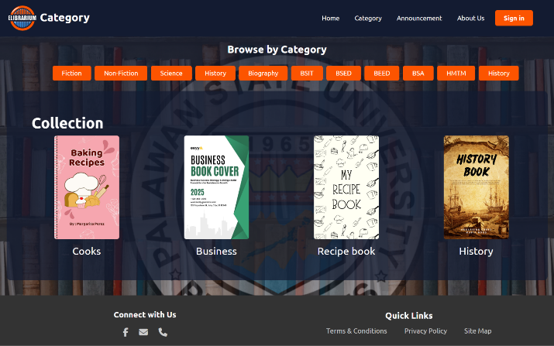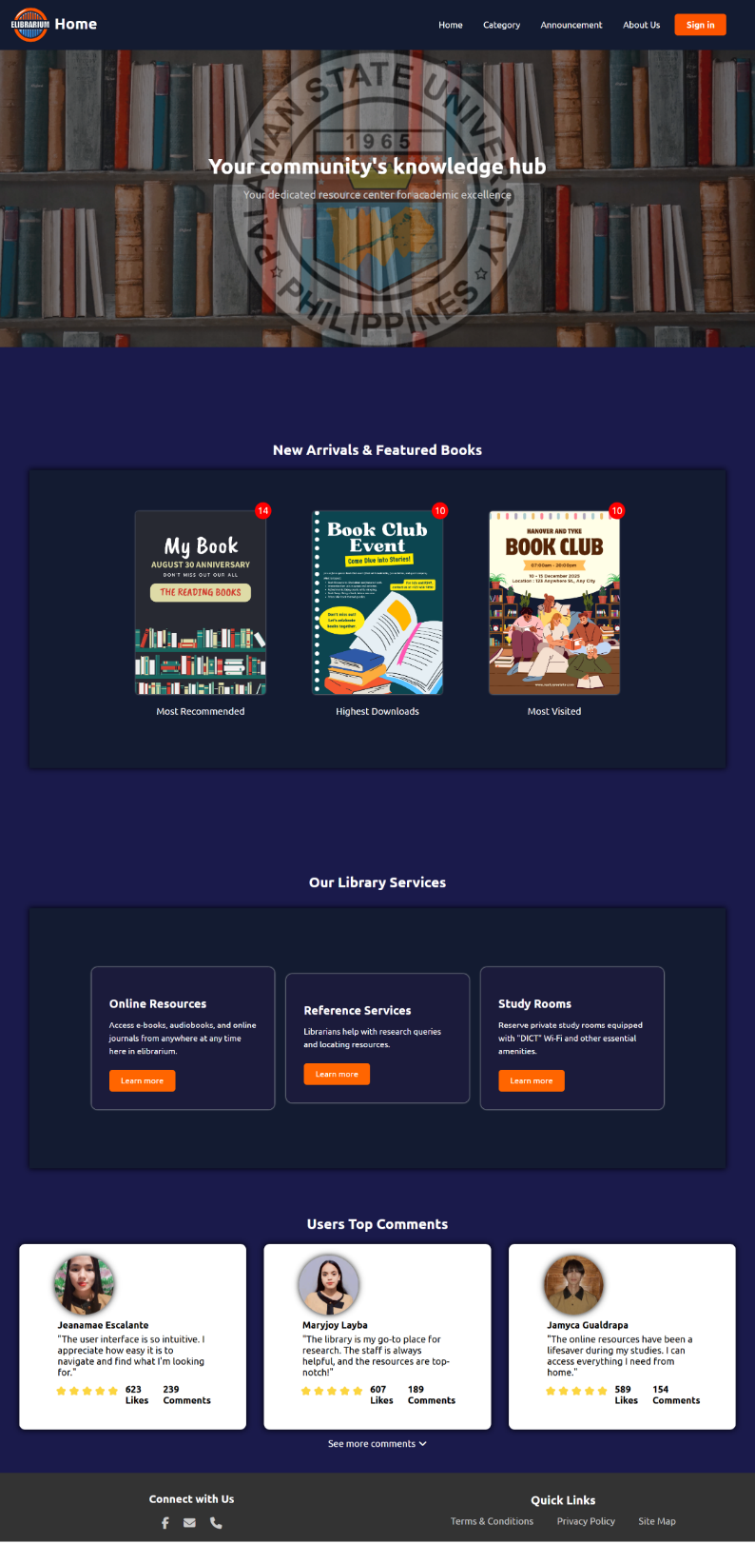**System/Software Requirements Specification**

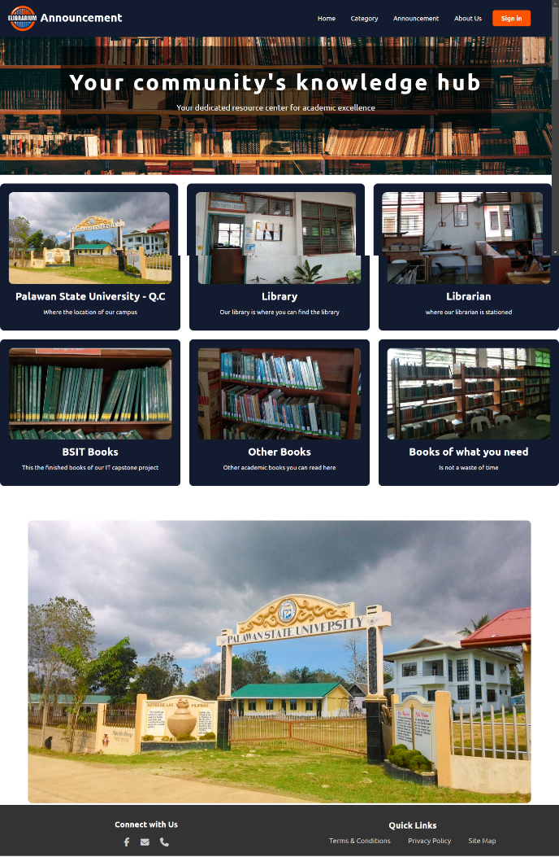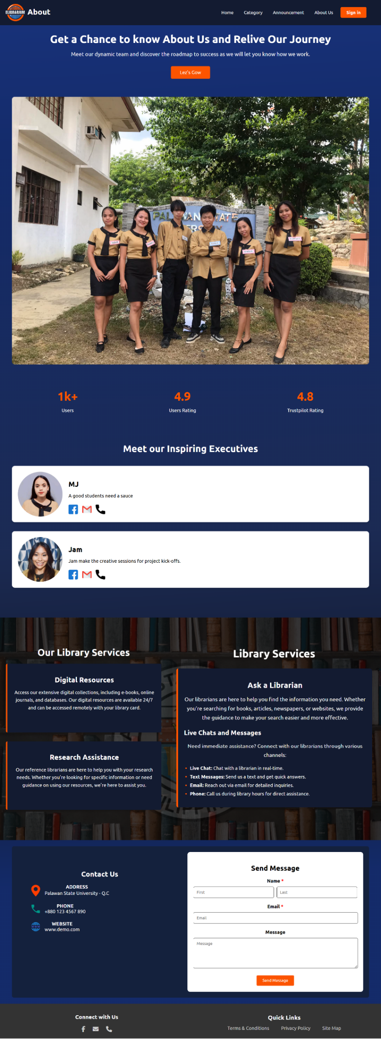

Figure 1.7: System*/Software Requirements Specification Functional*

**Elibrarium: Your Community’s Knowledge Hub**

Elibrarium is an academic resource platform designed to support students and faculty at Palawan State University. The homepage greets users with a welcoming design featuring the university seal and a clear navigation menu. Key sections include:

* **New Arrivals & Featured Books**: Highlights popular books with tags like “Most Recommended” and “Highest Downloads.”
* **Library Services**: Offers online resources (e-books & journals), reference services (research support), and study rooms for reserving private spaces.
* **User Testimonials**: Displays feedback from users, showcasing positive experiences and satisfaction with the platform’s resources.

The Category page allows users to explore various categories like Fiction, Non-Fiction, Science, History, and specific academic programs (e.g., BSIT, BSA). Featured books are categorized by genre, such as Business or History.

The Announcement page provides key information about campus resources, including the library, librarian support, and IT books for capstone projects, along with important university updates.

The About Us page introduces the team behind Elibrarium and highlights the platform’s success, with over 1k users and high satisfaction ratings. It also outlines services like digital resources, research assistance, and live chat support.

A Contact Us section is available for inquiries, offering contact details, a message form, and social media links.

Elibrarium is your go-to platform for academic resources, supporting students’ academic journeys with easy access to books, research assistance, and more.

**Requirements Documentation**

**Introduction**

This section outlines the methods and procedures used in developing the Elibrarium platform. It discusses the research methodology, including requirements analysis, documentation, and the design process for the system. The goal is to ensure that the platform meets the needs of the intended users, such as students, faculty, and librarians, while improving access to academic resources and streamlining library services. The section also highlights the role of each user within the system and explains how various system diagrams and components work together to meet their specific needs. By analyzing user roles and their responsibilities, this section ensures that the system’s design aligns with user requirements and enhances their academic experience.

**Purpose**

The purpose of this study is to develop an efficient and user-friendly system for managing academic resources at Palawan State University. The platform aims to provide students and faculty with seamless access to digital materials like e-books and journals, facilitate resource reservation, and enable easy communication with library staff. Through the system, users can easily browse, search, and reserve study spaces or resources, improving the overall efficiency of library services. Additionally, the platform simplifies the process of submitting service requests, managing announcements, and receiving timely notifications. The system serves as an effective communication and resource management platform, ultimately enhancing academic support services and user satisfaction.

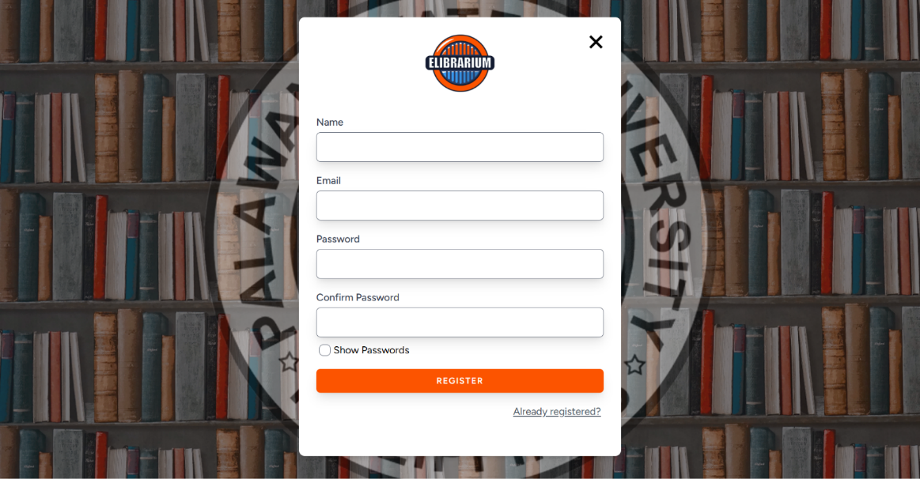**Design of Software, System, Product and/or Processes**

Figure 1.8: *Design of Software to Create Account*

**Create Account**

1. Visit the Website: Go to the official website.
2. Find sign-up or Register button: look for a “Create account”, button typically at the top-right corner of the page.
3. Provide Details: Enter your personal information like name, email and password. Some platforms might ask for a phone number or other details.
4. Verify email/phone: Check your email or phone for a verification link or code to confirm your account.
5. 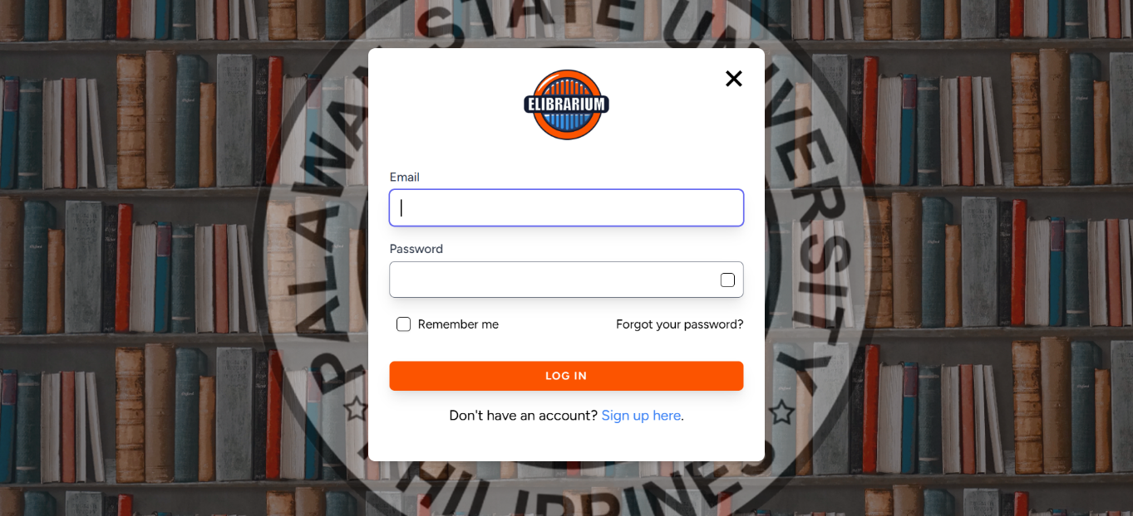Complete Setup: After verification, log in to your new account and complete any additional steps.

Figure 1.9: *Design of Software to Login*

**Log-in**

1. Email: A text box where users input their registered email.
2. Password: A password box where users enter their account password.
3. Submit Button: A button to a log in after entering credentials.
4. Forgot Password: A link to recover or reset the password.

**Non-Functional Requirements**

**Usability:** The system should feature a user-friendly interface that is easy to navigate and understand, providing clear and concise instructions. It must be accessible on various devices and platforms, catering to users with different levels of technological expertise.

**Security:** The system is required to incorporate robust security measures to safeguard user data and prevent unauthorized access. Utilizing encryption and multi-factor authentication will ensure data privacy and security, in compliance with relevant data protection laws and regulations.

**Reliability:** The system must be dependable and available at all times, minimizing downtime for maintenance or upgrades. Backup and recovery mechanisms should be in place to prevent data loss in the event of system failure or a disaster.

**Performance:** The system should be responsive and operate efficiently, boasting fast loading times and minimal delays. It must be capable of handling large volumes of traffic and user requests without compromising functionality or usability. Availability: The system must be consistently available to users, with minimal downtime for maintenance or upgrades. Incorporating failover and redundancy mechanisms will guarantee the continuous availability of critical services.

**Scalability:** The system needs to be designed to accommodate growth and changes in user demands, allowing for the scaling up or down of resources as needed. It should handle increasing user traffic and data volumes without compromising performance or reliability.

**Requirements Documentation**

This document is to define the functional requirements for the development of an elibrarium system for Palawan State University Quezon Palawan. This system will serve as a digital platform that enables Students and Faculty to access eBooks academic resources of the library management process.

The elibrarium system will include the following features:

* Online catalog of books, and other resources.
* User authentication and access control for students and faculty.
* Reporting tools for library staff usage statistics, inventory management.

**Stakeholders**

* Students/Faculty: End users who will access resources.
* Library personnel: Administrators managing the elibrarium content and inventory

**Design of Software, Systems, Product, and/or Processes**

This section will present various diagrams that illustrate design of software, system, products, and processes. The purpose of these diagrams is to provide a better understanding of the system being developed. This section serves as a valuable tool for researchers who are studying the development and implementation of the system. By examining the design diagrams, researchers can gain insights into the functionality and architecture of the system and can use this information to make informed decisions and recommendations for future improvements.

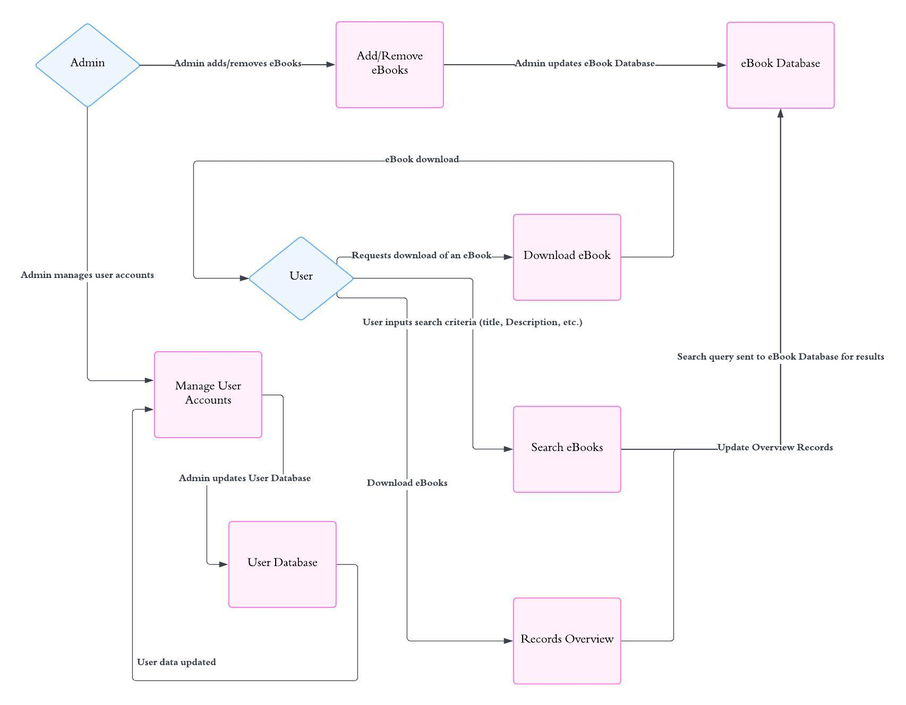**Data flow Diagram**

Table 1.9.1: *Data flow Diagram*

The data flow within the Elibrarium system follows a modernized process that enhances the service interaction between students and the librarian. The process begins with students registering their information, which is then recorded in the user management system by the librarian. Students can view the eBooks uploaded by the librarian. The system also allows the librarian to upload new eBooks and requested academic materials, after which students can proceed to read and download the eBooks.

**Entity Relationship Diagram**

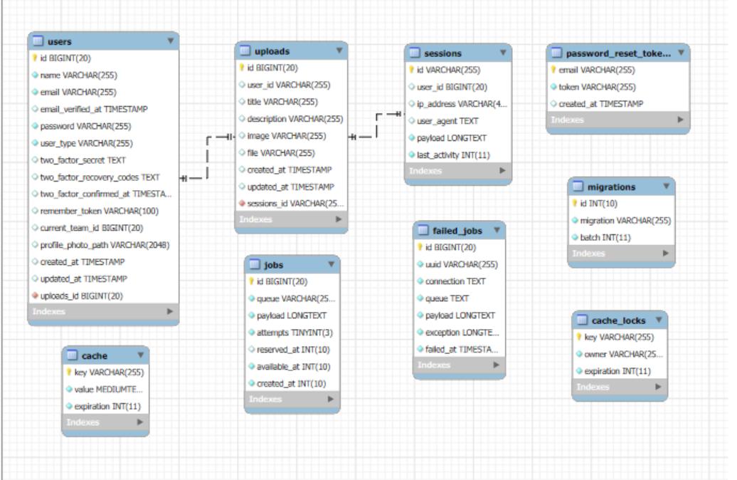

Figure 2.0: *Entity Relationship Diagram*

This was the researcher's entity relationship diagram, designed to visualize the initial stages of a database and determine information system requirements throughout an organization, aiding in the database design process. The structure and relationships of the database schema enabled the B-Connect system to fulfill its objectives of improving community participation, communication, and information sharing within PSU-Quezon Campus. It provided students with access to up-to-date information and the ability to download eBooks, can make feedback and request services.

**Network Topology and Architecture** 



User Devices Web Server Application Server



**File Storage/CDN Data Server**

Figure 2.1*: Network Topology and architecture*

The network topology starts with the User Device(client), which can be a computer, tablet, or smartphone, sending requests to the Web Server. The Web Server is responsible for serving static content like HTML pages, CSS stylesheets, and JavaScript files that make up the user interface of the application. When the request requires dynamic content, such as fetching user data, submitting a form, or processing a transaction, the Web Server forwards the request to the Application Server.

The application server handles the core business logic, processes the request, and may query the database server to retrieve or modify data, such as user profiles, product details, or order history. The database server stores all persistent data in structured formats and responds with the necessary information for the application server to return to the user.

For large files of documents, the application or web server may also interact with a File Storage/CDN (Content Delivery Network). The CDN is a distributed system that caches and serves static content from locations closer to the user, ensuring faster load times and reducing server load. The \*\*CDN\*\* can also help with scaling the delivery of large files by distributing the load across multiple edge servers globally.

This multi-tier architecture separates the responsibilities of different components, allowing each to scale independently and ensuring that the system can handle increasing user traffic, provide a fast user experience, and remain secure and maintainable.

**CHAPTER V**

**RESULTS AND DISCUSSION**

**Development and Testing**

|  |  |  |  |  |  |  |  |  |
| --- | --- | --- | --- | --- | --- | --- | --- | --- |
| Task Name | 2024 | | | | | | | |
| April | | | | May | | | |
| W1 | W2 | W3 | W4 | W1 | W2 | W3 | W4 |
| SYSTEM CONCEPTUALIZED |  |  |  |  |  |  |  |  |
| SYSTEM ANALYSIS |  |  |  |  |  |  |  |  |

|  |  |  |  |  |  |  |  |  |  |  |  |  |
| --- | --- | --- | --- | --- | --- | --- | --- | --- | --- | --- | --- | --- |
| Task Name | 2024 | | | | | | | | | | | |
| July | | | | AUG | | | | SEPT | | | |
| W1 | W2 | W3 | W4 | W1 | W2 | W3 | W4 | W1 | W2 | W3 | W4 |
| DESIGN |  |  |  |  |  |  |  |  |  |  |  |  |
| CODING |  |  |  |  |  |  |  |  |  |  |  |  |
| TESTING |  |  |  |  |  |  |  |  |  |  |  |  |
| IMPLEMENTATION |  |  |  |  |  |  |  |  |  |  |  |  |
| MAINTENACE |  |  |  |  |  |  |  |  |  |  |  |  |

Table 1.5: *Development and Testing*

Gant Chart

This table shows the time spent by the research in developing the Elibrarium: An Online Library Access for the Palawan State University, Quezon Campus.

**Conceptualized** - The process is started at third week of April, in continue at third week of May until last week of May.

**Analysis** - This process is a continuation of the study Elibrarium: An Online Library Access for the Palawan State University, Quezon Campus. Reviewing the website took four weeks, started on the last week of April and continue until the two weeks of May.

**Design**- the design of the website started at two weeks of August until the first week of September.

**Coding** - the coding started at second week of august the first layout of the website user-interface, it’s started in the Second week of august until third week of September.

1. **System Development**

The Elibrarium system underwent a comprehensive development process aimed at to display the eBooks reading and academics materials that the students need. This involved defining system requirements based on PSU-Quezon librarian specific needs and implementing key functionalities, including user roles, e-services management such as requesting eBooks, uploading more academics materials, submitting rate, feedback, and enhancing information through the announcement and gmail feature. Additionally, security measures were integrated to ensure the protection of user data and system integrity. The system Limits the User Privileges, it assigns negligible user privileges to accounts to reduce the potential impact of security breaches. It has a firewall to control and block unauthorized or suspicious connections in the platform, the system also has authentication such as email verification suggests an eight characters long password, and makes it encrypted for every account so the data converts into an unreadable one.

1. **User Roles Assignment**

The researchers ensured that everyone using the system had specific roles that fit their needs. The PSU-Quezon library librarian was given the most important role, acting as the system's administrator to keep things running smoothly. Students were given the role of user. Each user had the same levels of access and things they could do in the system. This setup made sure students could use the system for what they needed, while also keeping everything safe and secure. The researchers made sure everyone understood what they could and couldn't do in the system. The researchers provided clear instructions and help to anyone who needed it. This way, everyone could use the system confidently, knowing they were doing things right. By organizing things this way, the Elibrarium system not only made things easier for everyone but also made sure everything ran smoothly in Library at Psu-Quezon Campus. It also set the stage for future improvements and changes as needed

1. **Teaching and Presentation**

User adoption was prioritized by providing clear instructions and conducting training sessions for both the librarian and students. These sessions aimed to assist users in better understanding the B-Connect system, addressing any questions or concerns they had during teaching and testing, and providing detailed guides for future reference. The main goal was to ensure that users felt comfortable using the Elibrarium system by explaining its features and functions. Throughout these sessions, we ensured that any issues arising during testing were addressed to ensure a smooth transition to the new system. Moreover, these sessions were utilized to distribute comprehensive user guides and documents, carefully created to offer detailed instructions on utilizing the various functions of the Elibrarium system. The researchers aimed to provide users with the knowledge and skills necessary to effectively use the Elibrarium system and also ensured to encourage continuous learning and support, so users could seek assistance whenever needed.

1. **Pilot Implementation**

The researchers-initiated a thorough pilot implementation process to ensure the effectiveness and suitability of the elibrarium system before its full-scale deployment. This involved conducting tests in a controlled environment to assess its functionality and usability. A pilot implementation was carried out with a diverse user group comprising at least 25 individuals covering various age brackets, including Students of every program, seniors, and our classmate. To initiate this phase, the researchers actively engaged with the students, visiting their classroom to request a small amount of time for the pilot implementation. Throughout this pilot phase, feedback was carefully collected from users regarding their satisfaction and any identified issues or challenges they encountered while using the system. This feedback was then carefully analyzed and used to refine and improve the system to better meet the needs and expectations of its users.

1. **Full Implementation (not complete)**

Following the successful completion of the pilot phase, the researchers proceeded with the full implementation of the Elibrarium system, which was a big step forward in improving library service for librarian at PSU-Quezon campus library. Firstly, an official launch date was scheduled in close collaboration with PSU-Quezon librarian, taking into account community events and schedules to maximize participation and awareness. As part of the deployment strategy, the researchers opted to utilize InfinityFree, a reliable web hosting platform known for its free website domain, robust infrastructure and user-friendly interface. InfinityFree was chosen for its scalability, security features, and not just affordability but also free, ensuring seamless access to the Elibrarium system for all users. Furthermore, to enhance communication and engagement. Throughout the initial rollout phase, close monitoring of system performance was maintained to immediately address any emerging concerns or technical bugs. This proactive approach ensured that any issues were promptly identified and resolved, guaranteeing a positive user experience during the transition to full public access.

1. **Continuous Improvement**

Ensuring the ongoing enhancement and maintenance of the Elibrarium system is crucial for its long-term success. To achieve this, a structured approach is implemented, beginning with the establishment of a mechanism for collecting user feedback. This involves actively soliciting input from users to identify areas for improvement and address any issues they encounter. Additionally, regular updates are provided to address problems and, whenever feasible, introduce new features to enhance user experience and system functionality. To further support continuous improvement efforts, consideration is given to the possibility of assigning or hiring personnel dedicated to overseeing and implementing system enhancements on an ongoing basis.

**Implementation Plan (Infrastructure/Deployment)**

**System Infrastructure**

****

****

**Database**

****

**Server**

Figure 2.3: *System Infrastructure*

A client-server website only allows the user interacts with the developer who operate the system they will input, save, and store the data or information from the client.

**System Deployment**

**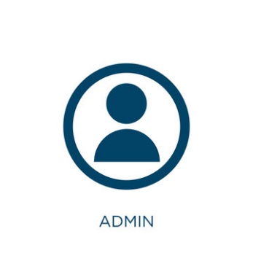**

****

User

**Database**

**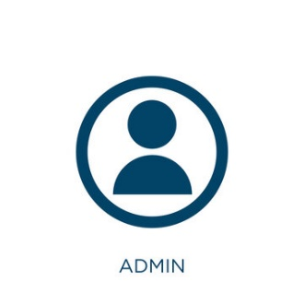**

**Server**

User

**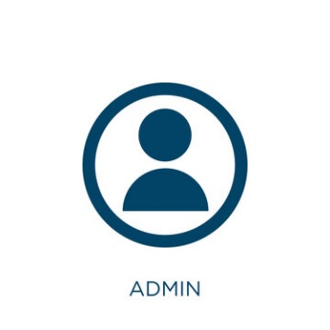**

User

Figure 2.4: *System Deployment*

The diagram illustrates a centralized system where admins connect to a server that manages requests and communicates with a database for data storage. This setup ensures secure and efficient interaction between users, the server, and the database for managing platform operations.

**Network Topology**



**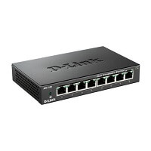**

**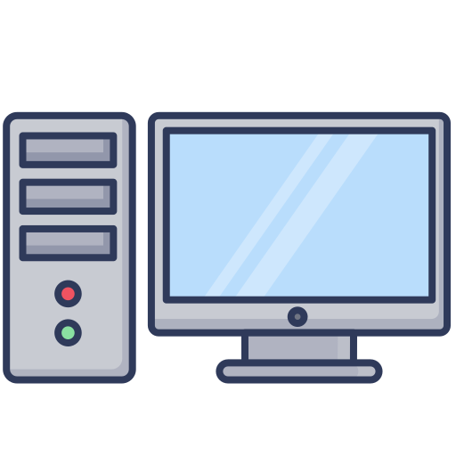**

****

Figure 2.5: *Network Topology*

Server is the administration that connect directly to a central server that manage communication, processing client without any interrupt with other.

**Security**

The users will be able to login to the website. The user will have access to the Elibrarium: An Online Library Access for the Palawan State University, Quezon Campus. Admin identifies the potential risks, outlines the necessary controls and processes and assigns roles and responsibilities to employees.

**Deployment Diagram**

|  |
| --- |
| Install Visual studio code  And MySQL |



|  |
| --- |
| C:\Users\ACER\Downloads\OIP.jfif |

****

|  |
| --- |
| C:\Users\ACER\Downloads\database_server.jpg  Database Server |

|  |
| --- |
| Files |

Figure 2.6*: Deployment Diagram*

The deployment diagram illustrates the physical architecture of the Elibrarium system, showing the interaction between various components, including client devices, web servers, and database servers, along with the communication paths and services they provide for seamless access to digital library resources.

**Implementation Results(not complete)**

**Usability Test Result**

The following pictures are the results of the usability testing conducted by the researchers in Palawan State University Quezon Campus during the first semester of 2023-2024.

**Results and Discussion**

The following pictures are the results of the survey conducted by the researchers in Palawan State University Quezon Campus during first semester of 2024-2025.

Figure 2.6.1*: Survey Question 1*

Out of 325 students, 6% (21 students) visit the library daily, while the majority (32%, 104 students) visit weekly. 27% (87 students) visit monthly, and 24% (79 students) visit rarely. 10% (34 students) never visit the library, indicating that most students use the library regularly, though daily visits are less common.

11

Figure 2.6.2: *Survey Question 2*

Of the 325 students, 54% (176 students) spend 10–30 minutes searching for books. 31% (102 students) spend less than 10 minutes, while 9% (29 students) spend 30–60 minutes. Only 3% (9 students) spend more than an hour searching, and another 3% (9 students) don't spend much time at all. This indicates that most students are efficient in their search for books.

Figure 2.6.3: *Survey Question 3*

37% (121 students) encounter challenges in finding books, suggesting some difficulty with the library’s organization or book availability. However, 60% (196 students) do not face challenges, indicating that the library works well for most users.

Figure 2.6.4: *Survey Question 4*

Among the 325 students, 39% (128 students) visit for reading or studying, and 37% (119 students) visit for research work. 13% (42 students) visit for group discussions or meetings, and 7% (24 students) visit to borrow books. A small group (4%, 12 students) cited other purposes for their visits.

Figure 2.6.5: *Survey Question 5*

Satisfaction with the library services varies. 12% (40 students) are very dissatisfied, 37% (120 students) are dissatisfied, and 31% (102 students) are neutral. 14% (47 students) are satisfied, and 5% (16 students) are very satisfied. This shows that while a majority have concerns, a portion of students are satisfied with the library services.

Figure 2.6.6: *Survey Question 6*

Of the 325 students, 65% (211 students) rarely find the library crowded or lacking study spaces. 20% (64 students) occasionally encounter this issue. 13% (41 students) never find the library crowded, and only 2% (8 students) frequently or always find it lacking space. This suggests that space is generally adequate for most students.

Figure 2.6.7: *Survey Question 7*

52% (170 students) feel that the study spaces mostly meet their needs, while 20% (65 students) find them completely adequate. 22% (73 students) are neutral, and 6% (17 students) feel the spaces are lacking or very inadequate. This indicates that while most students find the study spaces sufficient, there is still room for improvement in terms of comfort and facilities.

Figure 2.6.8: *Survey Question 8*

A strong majority of students (83%, 271 students) find the library hours convenient, while 16% (51 students) find them inconvenient. This suggests that the current library schedule works well for most students.

Figure 2.6.9: *Survey Question 9*

79% (256 students) are able to find the books and materials they need sometimes, and 12% (40 students) can always find them. Only 8% (27 students) rarely find the materials they need, and 1% (1 student) never can. This suggests that for most students, finding the necessary resources is not a major issue.

Figure 2.6.10: *Survey Question 10*

The condition of the library resources is rated positively by most students. 61% (197 students) rate the resources as good, while 24% (77 students) rate them as excellent. 15% (50 students) consider the resources to be average, and only 1% (1 student) rate them as poor. This indicates that the overall quality of library materials is satisfactory for the majority.

Figure 2.2.11: *Survey Question 11*

A significant 82% (268 students) would prefer an online platform to access e-books rather than visiting the physical library. Only 8% (27 students) would not prefer this option, and 9% (30 students) are unsure. This suggests a strong preference for digital resources, with many students seeing online access as more convenient.

**CHAPTER VI**

**CONCLUSIONS AND RECOMMENDATIONS**

**Conclusion**

Elibrarium has proven to be an innovative solution aimed at improving the accessibility of academic resources, simplifying research tasks, and encouraging greater community engagement at Palawan State University. This web-based platform enables smooth and transparent communication between students, faculty, and librarians, addressing key challenges in resource discovery and academic support. By using technology, Elibrarium makes learning more efficient, enhances resource management, and fosters academic excellence. As the platform continues to develop, it will empower users to easily access academic materials and engage more actively within the academic community, creating a more efficient, accessible, and inclusive learning environment. Elibrarium highlights the potential of technology to revolutionize education, connecting students and resources in ways that were not possible before.

A standout feature of Elibrarium is its ability to provide easy access to e-books and journals, allowing both students and faculty to explore a wide array of academic resources from anywhere. By offering a centralized library of materials with tools for searching, browsing, and reserving, the platform not only improves the management of resources but also lightens the workload for librarians. It also improves the delivery of services by allowing users to view library announcements, check book availability, and reserve study spaces, all from the platform. Elibrarium’s intuitive interface makes it easy for students to engage with the system, reducing the need for physical visits and long wait times at the library. Additionally, the platform’s SMS notification feature keeps users informed about the status of their requests, such as when a book or study room reservation is confirmed, ensuring quick and efficient communication. Based on the feedback gathered during the initial deployment, Elibrarium is expected to significantly enhance user satisfaction, streamline resource management, and improve the overall effectiveness of academic services at the university in the long term.

**Recommendations**

**REFERENCES**

**Foreign Literature**

**Thangiah, R., Leo, M. J. A., Suraj, A. M., & Ramar, R.** (2024). *Digital transformation of academic libraries.* In K. R. Senthilkumar (Ed.), **AI-assisted library reconstruction** (pp. 307-328). IGI Global. https://doi.org/10.4018/979-8-3693-2782-1.ch017

**Carvalho e Rodrigues, M., & Mandrekar, B**. (2020). *Impact of academic library services on students' success and performance. Library Philosophy and Practice* (e-journal). https://digitalcommons.unl.edu/libphilprac/4246

**Igwe Ukoha O.** (October 2020). *Libraries without walls and open and distance learning in Africa: The Nigerian experience. Library Philosophy and Practice*. https://www.researchgate.net/publication/242268310

**Local Literature**

**Panhilason, A. P**. (2024). *Users’ awareness, utilization, and satisfaction with online library information resources and services. Journal of Interdisciplinary Perspectives*, *2*(3). https://ejournals.ph/article.php?id=22718

**Lagas, S., & Isip, J**. (2023). *Challenges to digital services in Philippine academic libraries. Philippine Journal of Librarianship and Information Studies, 43*(1), 27–38. https://phjlis.org/index.php/phjlis/article/view/133

**Agustian, H., & Nugraha, A**. (2021). *E-book limitation with library portable document format java script for accessing digital library. Compiler: Journal of Computer Science and Information Technology, 10*(1). https://doi.org/10.28989/compiler.v10i1.960

**Foreign Studies**

**Khan, R**. (2021). *Importance of digital library in education. International Journal of Research in Library Science, 7*(4), 102-117. https://doi.org/10.26761/IJRLS.7.4.2021.1467

**Ogata, K., & Fujita, S**. (2023). *Decentralized storage with access control and data persistence for e-book stores. Future Internet, 15(406), 1-20.* <https://doi.org/10.3390/fi15120406>

D'Ambra, J., Akter, S., & Mariani, M. (2023). Digital transformation of higher education in Australia: Understanding affordance dynamics in e-textbook engagement and use. Computers in Human Behavior, 139, 107514. <https://doi.org/10.1016/j.chb.2022.107514>

**Local Studies**

**Abrigo, D. M. E., Eclevia, M. R., Samson, K. B., & Viray, M. R. A.** (2023). *Teaching information literacy during the pandemic: Current practice and challenges. PAARL Research Journal, 9(*1). https://ejournals.ph/article.php?id=20038

**Calilung, R. P**. (2024). *Librarians in transition: Empowering knowledge seekers in the digital age. EPH-International Journal of Educational Research, 8*(1), 42-49. https://doi.org/10.53555/ephijer.v8i1.111

**Narca, J. R. G.** (2021). *COVID-19 pandemic and the library online services: SSC Manila high school librarians' experiences. International Journal of Asian Education, 2*(4), 589-597. <https://doi.org/10.46966/ijae.v2i4.219>